Software Development Life Cycle (SDLC) Documentation

Project Title: Real-Time Collaborative Whiteboard Application
Attribute | Detail
Project Type | Mini Project / Web Application
Development Model | Agile (Iterative/Incremental)
Target Users | Remote teams, students, and educators
Goal | To allow multiple users to draw, sketch, and annotate together on a shared canvas in real-time.

1. Project Scope and Requirements Analysis (SRS)

1.1 Project Goals
The primary goal is to provide a seamless, low-latency collaborative drawing experience with user authentication and persistence.

1.2 Functional Requirements (FR)
ID | Requirement | Description
FR-001 | User Authentication | Users must be able to sign up, log in, and log out.
FR-002 | Whiteboard Creation | Authenticated users can create new whiteboards, each with a unique shareable URL.
FR-003 | Real-Time Sync | All drawing actions (strokes, color changes) must be instantly visible to all users concurrently viewing the same whiteboard.
FR-004 | Drawing Tools | Must include Pencil, Eraser, Color Picker, and Stroke Size selection.
FR-005 | Canvas Persistence | All drawing data must be saved and retrieved upon reloading the whiteboard.
FR-006 | Undo/Redo | Users must have the ability to undo and redo their last few actions.

1.3 Non-Functional Requirements (NFR)
ID | Requirement | Category
NFR-001 | Latency | Real-time synchronization latency must be below 100ms for concurrent users (Performance).
NFR-002 | Scalability | The backend must support up to 10 concurrent users per whiteboard (Scalability).
NFR-003 | Security | Only authenticated and authorized users can access a specific whiteboard (Security).
NFR-004 | Usability | The user interface must be intuitive and responsive on desktop and tablet devices (Usability).

2. System Design

2.1 Technology Stack
Component | Technology | Rationale
Frontend | React + Canvas API | Component-based, efficient DOM updates, and direct access to drawing canvas.
Backend | Node.js (Express) | High performance, single-threaded, and excellent for I/O and handling many concurrent connections.
Real-Time | WebSocket (Socket.IO) | Necessary protocol for bidirectional, persistent, low-latency communication.
Database | MongoDB / Firestore | Flexible document storage for complex stroke data (JSON/BSON) and easy scaling.

2.2 System Architecture (High-Level Design)
The application uses a three-tier architecture with a crucial real-time layer.
Explanation:
- Client: The React application renders the canvas. It sends drawing actions as WebSocket messages.
- WebSocket Server (Dedicated): Handles all real-time drawing events. When it receives a stroke from User A, it broadcasts the stroke data to all other connected clients (Users B, C, D) on the same whiteboard channel.
- Application Server (REST API): Handles non-real-time actions like Authentication (Login/Signup), Whiteboard Creation, and saving the final state on disconnection.
- Database: Stores user records and persistent whiteboard data (a list of all drawing strokes).
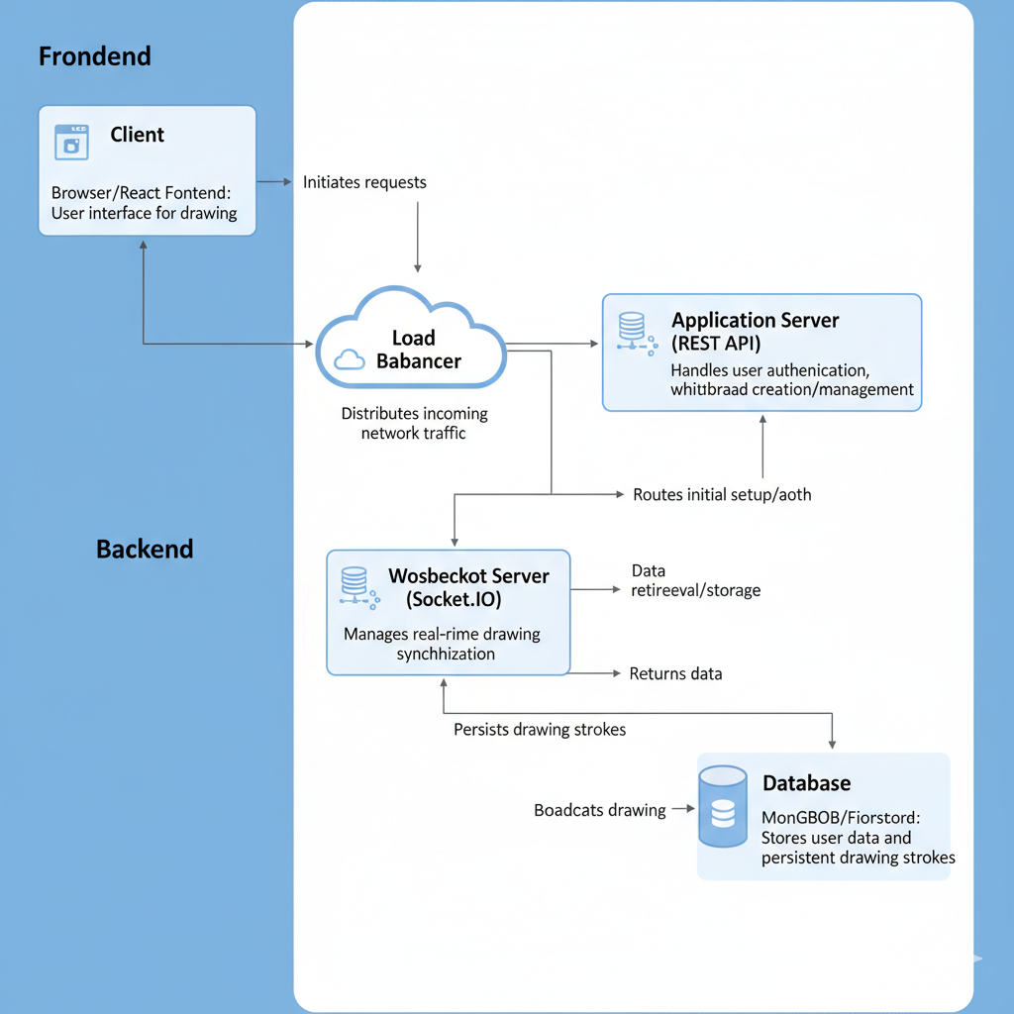

2.3 Data Flow Diagram (DFD - Level 1: Drawing Action)
This diagram shows the flow for a single drawing stroke.
- User A Draws a line.
- Client: Emits a DRAWING_ACTION WebSocket message with stroke coordinates, color, and size.
- WebSocket Server: Receives the message, processes it, and sends the action data to two destinations:
  - Broadcast: Sends the action to all other connected clients on that room ID.
  - Persistence: Sends the action to the Database Service for saving.
- Other Clients (B, C, D): Receive the broadcasted message and render the new stroke on their respective canvases.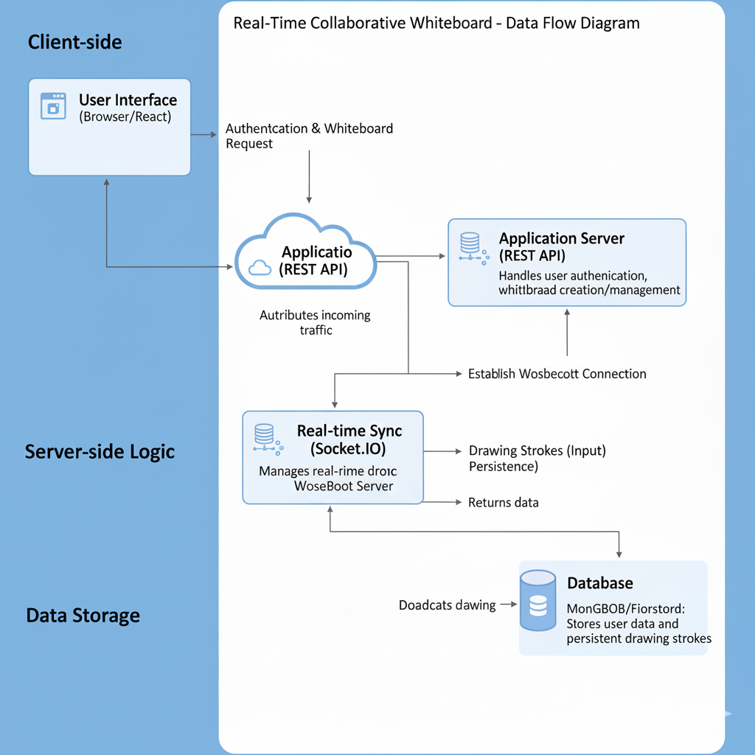
- Database: Appends the new stroke object to the whiteboard's stroke list.

2.4 Database Schema (Simplified - Whiteboard Collection)
Field Name | Data Type | Description
_id | ObjectId | Unique ID for the whiteboard document.
title | String | User-defined name of the whiteboard.
ownerId | String | ID of the user who created the board.
sharedWith | Array of Strings | List of user IDs authorized to access this board.
strokes | Array of Objects | The core data structure for the canvas content.
strokes[].type | String | e.g., 'line', 'eraser', 'circle'.
strokes[].data | Array of Coordinates | The actual path coordinates ([{x: 10, y: 50}, {x: 12, y: 55}, ...]).
strokes[].color | String | Hex code of the stroke color.
strokes[].size | Number | Thickness of the stroke.
createdAt | Date | Timestamp of creation.
updatedAt | Date | Timestamp of last modification.

3. Implementation and Coding

3.1 Development Sprints (Agile Approach)
Sprint | Duration | Deliverables (User Stories)
Sprint 1 | 1 Week | Foundation: Setup project structure, create basic user sign-up/login, and a static HTML canvas (no drawing yet).
Sprint 2 | 2 Weeks | Core Drawing: Implement basic Pencil tool, ability to save and load a single stroke locally, and establish the WebSocket connection (Pinging).
Sprint 3 | 2 Weeks | Real-Time & Persistence: Implement real-time synchronization of drawing actions across two clients, connect the backend to the database to persist stroke data.
Sprint 4 | 1 Week | Feature Polish: Implement Eraser tool, Undo/Redo functionality (using command pattern), and final UI adjustments (Color Picker, Size Slider).
Sprint 5 | 1 Week | QA & Deployment: Final bug fixes, performance testing, and initial staging deployment.

3.2 Key Technical Challenges
- Data Serialization: Efficiently serializing and deserializing large arrays of stroke coordinates for transmission over WebSockets and storage in the database.
- Conflict Resolution: Ensuring strokes from multiple users are applied in the correct, sequential order without causing graphical glitches. This will require strict message timestamping.

4. Testing and Quality Assurance (QA)
The testing strategy covers functionality, integration, and non-functional performance.
Test Type | Objective | Key Test Cases
Unit Testing | Verify individual components (e.g., Auth service, Undo stack, Canvas drawing logic). | Test login() with invalid credentials; test pushStroke() on the Undo stack.
Integration Testing | Verify communication between the Client, WebSocket Server, and Database. | User logs in -> creates board -> draws stroke -> stroke appears in the database.
Concurrency Testing | Check the real-time stability under load (NFR-002). | 5 users simultaneously draw on the same board for 5 minutes; measure latency and data loss.
Security Testing | Verify authentication and authorization mechanisms (NFR-003). | Attempt to access a private whiteboard URL without logging in; attempt to modify a stroke created by another user.

5. Deployment and Maintenance

5.1 Deployment Strategy
- Environment: Cloud hosting service (e.g., AWS, GCP, Azure).
- Architecture: The Application Server and WebSocket Server should be deployed on separate, containerized instances (e.g., Docker) and managed by a service like Kubernetes for horizontal scaling.
- CI/CD: Use a Continuous Integration/Continuous Deployment pipeline (e.g., GitHub Actions or Jenkins) to automate testing and deployment upon merging to the main branch.

5.2 Maintenance Plan
- Monitoring: Implement monitoring tools (e.g., Prometheus/Grafana) to track WebSocket connection stability, server latency, and database query performance.
- Updates: Regular dependency updates (Node.js, React) and security patching.
- Feature Roadmap (Future Enhancements): Text tool, image insertion, shape drawing, and improved mobile support.

6. Entity-Relationship Modeling
To complement the database schema defined in Section 2.4, this section details the logical relationships between the system entities.

1 Entities and Attributes
- User: UserID (PK), Username, PasswordHash, CreatedAt.
- Whiteboard (Room): RoomID (PK), OwnerID (FK), Title, IsPublic, CreatedAt.
- Stroke: StrokeID (PK), RoomID (FK), UserID (FK), Color, Size, PathData, Timestamp.

2 Relationships and Cardinality
- User -- creates -- Whiteboard:
- Relationship: One-to-Many (1:N).
- Description: A single authenticated user can create multiple whiteboards. A whiteboard must be owned by exactly one user.
- Whiteboard -- contains -- Stroke:
- Relationship: One-to-Many (1:N).
- Description: A whiteboard consists of thousands of stroke actions. Each stroke belongs to a specific whiteboard.
- User -- draws -- Stroke:
- Relationship: One-to-Many (1:N).
- Description: A user performs many drawing actions (strokes).

3 E-R Diagram Representation

7.2 Interface Screenshots
Figure 7.1: The Landing Page

Figure 7.2: The Main Collaborative Canvas

8. Detailed Test Case Execution Log
While Section 4 outlined the Testing Strategy, this section documents the specific execution of functional test cases.
TC ID | Test Scenario | Steps to Execute | Expected Result | Actual Result | Status
TC-01 | Create New Room | 1. Open App.  2. Click "Create Room". | System generates a unique Room ID (e.g., abc-123) and redirects to canvas. | Room ID generated, redirected. | PASS
TC-02 | Join Existing Room | 1. User A copies Room ID.  2. User B opens App.  3. User B pastes ID and clicks "Join". | User B enters the same session as User A. | User B joined successfully. | PASS
TC-03 | Real-Time Sync | 1. User A draws a circle.  2. User B observes their screen. | The circle appears on User B's screen within 100ms. | Circle appeared instantly. | PASS
TC-04 | Change Color | 1. Select "Red" from palette.  2. Draw a line. | Line renders in Red color. | Line is Red. | PASS
TC-05 | Eraser Tool | 1. Select "Eraser".  2. Drag over existing lines. | Lines under the cursor are removed/turn white. | Lines removed. | PASS
TC-06 | Session Persistence | 1. Draw on canvas.  2. Refresh the browser page. | Previous drawings should reload automatically. | Drawing reloaded from DB. | PASS

9. Conclusion
The Real-Time Collaborative Whiteboard Application was successfully designed, implemented, and tested.

9.1 Summary of Achievements
The project met all primary Functional Requirements defined in the SRS (Section 1.2). We successfully implemented:
- A low-latency drawing engine using HTML5 Canvas.
- A robust real-time communication layer using Socket.io.
- A scalable persistence layer using MongoDB.

9.2 Limitations and Future Scope
While the core functionality is stable, the following areas were identified for future improvement:
- Mobile Touch Support: Currently, the touch events on mobile devices lack pressure sensitivity.
- Vector Shapes: The current implementation uses raster graphics; moving to vector shapes (SVG) would allow for re-sizing existing drawings.
- User Accounts: Implementing OAuth (Google/GitHub Login) would improve security over the current anonymous session model.
This project demonstrates the efficacy of the MERN stack (MongoDB, Express, React, Node) combined with WebSockets for building high-performance, interactive collaborative tools.

